Year 13 Autumn Term Curriculum Plan 1
This document is designed to provide an overview of the content of the curriculum that each department will be addressing over the Autumn Term. Each department has provided information on the topics/ content addressed, resources being used and information on tasks that will be assessed. If you have any queries please direct these into the Progress Team on the email address below as a primary point of contact.
Communication Tools
Teachers may be sending activities home for pupils using one of three methods: Gmail, Teams or Google Classroom. All pupils have a Gmail address which allows them to access Google Classroom. The address is their 6 digit user number @ypant.co.uk and the password will be the same as the one they use to log into the computer at school. Pupils also have a HWB email address to access Teams.
HWB Teams
HWB Teams are online collaborative working environments for teachers and learners. Many classes have a Teams group and staff can post material, information and assignments in the classroom for pupils to view and complete.
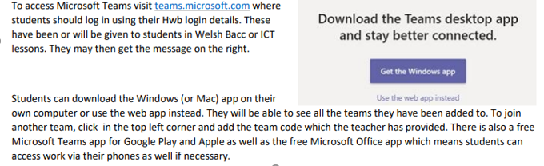
To access HWB Teams students should:

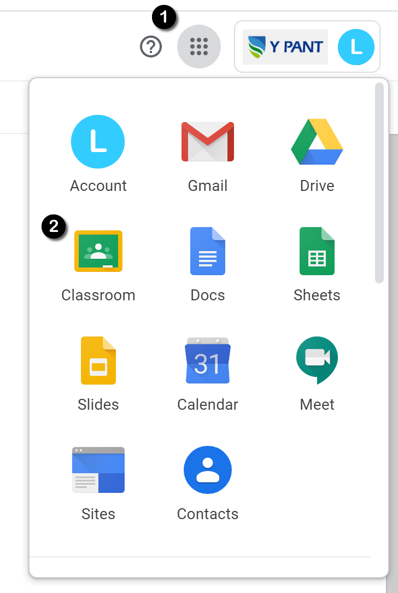
Google Classroom
Google Classrooms are online collaborative working environments for teachers and learners. Many classes have a Google Classroom and staff can post material, information and assignments in the classroom for pupils to view and complete.
To access Google Classrooms students should:
- Log in to their school Gmail.
- They will see the 9 dot icon the right-hand corner of the screen ❶
- By clicking this, students can access the full range of Google Suite for Education services including Google Classroom. ❷
- All of the classrooms a pupil has access to will appear in their browser so they can select the classroom of the subject they want to access.
- Google Classroom apps can also be downloaded for mobile devices and tablets and if push notifications are enabled, they will inform you of any new material or assignments as they are set.
HWB Teams
HWB Teams are online collaborative working environments for teachers and learners. Many classes have a Teams group and staff can post material, information and assignments in the classroom for pupils to view and complete.
To access HWB Teams students should:

Year Group Contact Details
Head of Progress | Mrs S. Nowell-Hughes | sixthform@ypant.co.uk
Assistant Head of Progress | Mrs G Lewis
Senior Leadership Link | Ms L. Bunce

Year 13 English
Topic Overview | John Donne poetry  The Handmaid’s Tale and The Secret Scripture coursework
Assessed  Tasks | Extract question on The Flea by John Donne  Coursework
Resources | Work on Teams and email your class teacher for further resources.
Year 13 Maths
Topic Overview | Unit 4 Statistics  Understand and use conditional probability, including the use of tree diagrams.  Understand and use the conditional probability formula: P (A Ç B) = P(A)P(B|A) = P(B)P(A|  Modelling with probability, including critiquing assumptions made and the likely effect of more realistic assumptions  The continuous uniform distribution  Finding probabilities using the normal distribution  Select an appropriate probability distribution for a context from binomial, poisson, uniform or normal)  Understand and apply hypothesis testing to correlation coefficients as measures of how close data points lie to a straight line and be able to interpret a given correlation coefficient using a given p-value or critical value.  Conduct a statistical hypothesis test for the mean of a normal distribution.  Unit 4 Mechanics·  Extend newton’s second law to situations where forces need to be resolved.  Resolve forces in two dimensions  Understand and use the equilibrium of a particle under coplanar forces  Understand and use the addition of forces, resultant forces and dynamics for motion in a plane.  Use the model for friction (F ≤µR)  The coefficient of friction  The motion of a body on a rough surface  Motion of a particle on an inclined plane  Limiting friction and statics  Unit 3 ( Pure Maths)  Work with radian measure (including arc length, area of a sector and the area of a segment)  Understand and use the definitions of sec x, cosec x and cot x  Solution of trig equations (using sec^x= 1 + tan^x and cosec^x = 1 + cot^x)  Solution of equations using the double angle formulae  Understand and use expressions in harmonic form( acosx + bsinx )  and solve equations using these.
Assessed  Tasks | Assessed homeworks  Half-term test
Resources | My Maths
Year 13 Biology
Topic Overview | Homeostasis and the Kidney - gross anatomy of the kidney, ultrafiltration, selective reabsorption, osmoregulation and renal failure  Respiration - to complete  Photosynthesis
Assessed  Tasks | Microbiology test  Respiration test  Homeostasis and the Kidney assessed homework
Resources | School produced booklets and lab booklets.  Homework set via Teams / SIMS  Home Learning: Microsoft team - A team has been created for each class and this will be managed by individual class teachers. Check Teams for scheduled virtual lessons (this may not always be appropriate).  Bioninja website
Year 13 Chemistry
Topic Overview | Equilibria constants and Acid Base equilibria booklet:  Equilibria; Calculating pH, pH curves, Indicators, Buffers, Salts.  Aromaticity and Isomerism( structure of benzene, reactions of benzene and its derivatives, optical isomerism), Nitrogen Chemistry (synthesis and reactions of primary amines, protein structure and synthetic polymers). Organic Synthesis and Analysis (ways of separation and purification).
Assessed  Tasks | Worksheets, key tasks within booklets.  End of unit tests
Resources | Departmental booklets. TEAMS classroom where additional instruction or work may be placed.  WJEC revision booklet and website
Year 13 Physics
Topic Overview | 1. Circular Motion: Radian Measure, Speed, Centripetal Acceleration and Centripetal Force.  2. Simple Harmonic Motion: Oscillation Terms and definitions, SHM, Mass-Spring Systems, SHM Equations and Graphs, Energy in SHM, Damped Oscillations and Resonance.  3. Kinetic Theory: Particle Model of a Gas, The Kinetic Model of a Gas, The Ideal Gas, Internal Energy, the Kelvin Scale, Gas Pressure, The Gas Laws and Moles and Relevant Equations.  4. Thermodynamics: Internal Energy and Factors that affect it, Changes of State, the Kelvin Scale, SHC, Thermal Equilibrium, The Laws of Thermodynamics and Work done on/by a Gas.  Skills include:  Numeracy, Literacy, Communication and Practical Skills, along with revision skills.
Assessed  Tasks | 1. 1 assessed homework task and an end of topic test.  2. 2 assessed homework tasks and an end of topic test.  3. 1 assessed homework tasks and an end of topic test.  4. 2 assessed homework tasks and an end of topic test.
Resources | Physics Booklets.  Watch Appropriate Scientific TV Programmes.  Read appropriate Newspaper Articles.  New Scientist Magazine.  OCR Physics for A2 Level.  Mathematics for A Level Physics – a course companion.  Selection of Books available from department – ask teachers for advice.  Teams Groups set up for each class.
Year 13 Art
Topic Overview | Unit 2 Personal Investigation  Personal Study and Practical Coursework Unit  Student selected focus of enquiry.  Students produce an in-depth illustrated personal study (3000words) showing analysis of selected Art works. This study will inform and inspire students own practical work. Students can work with any media. The emphasis is on ‘Personal’ and students must try to use their study to inform and inspire their practical study.
Assessed  Tasks | Ongoing assessment of practical work.
Resources | Sketchbook  Drawing and colour based media  Teams classroom ls3ii6j  Museum and gallery websites  AS/A Level Art and Design (wjec.co.uk)
Year 13 Business
Topic Overview | UNIT 4: Customers and communication  - Understand who customers are and their importance to businesses  - Understand how to communicate with customers  - Be able to establish a rapport with customers through non-verbal and verbal communication skills  - Be able to convey messages for business purposes  - Know the constraints and issues which affect the sharing, storing and use of information for business communications
Assessed  Tasks | Individual tasks to be handed in and assessed.  Students have individual deadlines.
Resources | https://ocr.org.uk/Images/294550-customers-and-communication.pdf
Year 13 Computer Science
Topic Overview | Unit 3 (KD)  - Economic, moral, legal, ethical and cultural issues relating to computer science  - Data structures  - Logical operations  Unit 5 (OC)  - Individual Programming Project
Assessed  Tasks | Class test on each of the Unit 3 topics listed above
Resources | Unit 3 support -Notes given in lessons  https://isaaccomputerscience.org/concepts/dsa_datastruct_definitions?examBoard=all&stage=all&topic=data_structures  https://isaaccomputerscience.org/concepts/prog_concepts_logical?examBoard=all&stage=all  Project Support-  https://www.wjec.co.uk/qualifications/computer-science-as-a-level/?sub_nav_level=course-materials#tab_resources
Year 13 Design Technology
Topic Overview | Final A-Level coursework - folder work, sketchbook and practical
Assessed  Tasks | Investigating the problems, coming up with briefs, End User Profile, specification, Initial Ideas, design development and modelling.
Resources | TEAMS assignments
Year 13 Drama
Topic Overview | Unit 3: Devising/Scipted  - Process evaluation section 1 (D/S)  - Scripted and devised rehearsal  Unit 4: Text in Performance  - Day in the Death of Joe Egg  - Actor/Designer/Director
Assessed
Tasks
Resources | TEAMS ACCESS - Individual channels and U3/U4 channel.  Day in the Death of Joe Egg script  Individual U3 script
Year 13 Medical Science
Topic Overview | The Digestive System - the mouth, oesophagus, stomach, peristalsis, small intestine, large intestine, deficiency diseases, coeliac disease.  Prescribing Drugs - How do drugs work? Unit 4 coursework
Assessed  Tasks | Immune System and Genetics test  Digestive System test
Resources | School produced booklets and lab booklets.  Homework set via Teams / SIMS  Home Learning: Microsoft team - A team has been created for each class and this will be managed by individual class teachers. Check Teams for scheduled virtual lessons (this may not always be appropriate).  Bioninja website
Year 13 Government and Politics
Topic Overview | Unit 3-  Political ideologies- Liberalism  Unit 4-  USA - US Constitution and Federalism
Assessed  Tasks | A mixture of structured questions and extended response questions- some timed.
Resources | WJEC Government & Politics website: https://www.wjec.co.uk/qualifications/government-andpolitics-as-a-level/#tab_overview  Keep up to date with American news and politics.  TEAMS CODE- 16fcubd
Year 13 Geography
Topic Overview | Unit 3: Global Systems and Global Governance  Section A: Global Systems: Water and Carbon Cycles  Section B: Global Governance: Change and Challenges  Section C: 21st Century Challenges
Assessed  Tasks | Two hours examination, worth 24% of the qualification. Four compulsory structured questions with data response and three extended response questions.
Resources | Microsoft Team set up for the cohort, code: h448ejt  All supporting resources on Teams in scheme of work order.  http://www.bbc.co.uk/coast/  http://www.soton.ac.uk/~imw/Lulworth.htm www.curriculum-press.co.uk http://www.worldatlas.com/webimage/countrys/asia/lgcolor/incolor.htm http://www.prb.org/pdf06/61.3IndiasPopulationReality_Eng.pdf  http://infochangeindia.org/Agriculture/  http://uk.youtube.com/watch?v=xybF8VQz8Vs  The following WJEC revision guides may be useful: https://www.hoddereducation.co.uk/subjects/geography/products/16-18/wjec-eduqas-a-level-geographystudent-guide-4  https://www.hoddereducation.co.uk/subjects/geography/products/16-18/wjec-eduqas-a-level-geographystudent-guide-3
Year 13 History
Topic Overview | Unit 3  • USA 1880-1980 module – Foreign Affairs  Unit 4  • Germany 1933-45  Unit 5  • Students start with their independent research for their Controlled Assessment task life in Britain during the Depression of the 1930’s. Teacher’s will provide full guidance at the time of teaching.
Assessed  Tasks | Regular past paper questions relating to the topic areas covered.  • Controlled Assessment research and essay
Resources | School produced booklets  History Channel  YouTube  Teams-  Miss Hodnett- az0ih5b
Year 13 Sociology
Topic Overview | Unit 3- Crime and Deviance- This half term we will be working through booklet 1- Crime and Deviance and exploring trends in crime. The notes and tasks are all enclosed in the booklet. Powerpoints will be uploaded to Teams  Unit 4 - Applied Research Methods. Mini booklets given out every two weeks and also uploaded to Teams along with accompanying PowerPoints (see the Unit 4 Channel - Files).
Assessed  Tasks | End of unit tests
Resources | Crime and Deviance booklet 1  Applied Sociological Research booklets  Textbook  Sociology Teams
Year 13 Media Studies
Topic Overview | Section A - Television in the Global Age. Exploring Crime Drama genre and set text Hinterland  Section B - Magazines  Introduction to the NEA and work on the Investigative Research essay
Assessed  Tasks | Section A - Hinterland assessment  Section B - Analysis of magazine set text
Resources | Check Teams for all resources  Use Netflix to access Series 1 episode 1 of Hinterland  Use Youtube to watch explanation and revision videos
Year 13 Physical Education
Topic Overview | Unit 1; Topics cover - Exercise Physiology; Sports Psychology and Socio Cultural Issues in Sport  Each of the three teachers will provide a specific topic from above.
Assessed  Tasks | Past paper questions for each topic above.
Resources | TEAM CODE: nhhtm64  School produced work booklet  Any homework will be on teams; pupils should work through workbook used in class if off with COVID.  WJEC Resources - https://resources.wjec.co.uk/pages/ResourceByArgs?subId=23
Year 13 Psychology
Topic Overview | Students will work through unit 4. Investigation 1 was completed before the summer holidays. Investigation 2 to be completed this half term. Students plan, conducts and write up the investigation. They will then work through the application section of unit 4 drawing upon year 12 research methods knowledge as well as a few new topics. If students are isolating they will be able to join the lessons live. All class materials will also be uploaded to teams (students must save their own copies before editing).
Assessed  Tasks | Investigation 1 assessment  Investigation 2 assessment  Self-assessed past paper/practice questions
Resources | Log books for each investigation and a booklet for the remainder of the unit 4 topics. Copies will be given to students and be available on teams.  Students can visit the bps website to research and look for recent publications relevant to our unit 3 topics (criminal and schizophrenia).  Students will need to purchase a text book by half term. The link is to amazon but can be purchased elsewhere https://www.amazon.co.uk/Complete-Companions-Psychology-PSYCHOLOGY-COMPANION/dp/0198356110/ref=sr_1_5?dchild=1&keywords=wjec+psychology+complete+companion&qid=1632824955&qsid=257-0550999-5044616&sr=8-5&sres=B01LL8YTD8%2C1850085714%2C0198356102%2C0198359179%2C0198356110%2CB0182PWSUO%2C0198436335%2C0198436327%2C1850084408%2C0199136173%2CB00GQ68L0S%2CB011T8OT7Q%2CB00M8OZJES%2CB00ZLVQPAC%2CB00GEH27YA%2C1782943307&srpt=ABIS_BOOK
Year 13 Welsh
Topic Overview | Unit 4 - Crash (Speaking)  Unit5 - Cymraeg yn y Gymdeithas & Trawsieithu  Unit 6 - Straeon byrion (short stories) & Gramadeg
Assessed  Tasks | Regular past paper questions relating to each module
Resources | School produced booklets  School produced PPT  Resources for each lesson will be emailed to your school email account by your teacher for that module.
Year 13 Welsh Baccalaureate
Topic Overview | Enterprise & Employability Task 2
Assessed  Tasks | The Innovation Proposal should be presented as a report and include:  - An executive summary of innovation concept/idea;  - Roles and responsibilities: critically assess suitability for roles and allocate responsibilities;  - Innovation of an existing or new product/ service: conduct ideas screening; potential ideas, appraisal of ideas and rationale for decisions made;  - A feasibility study: utilise business analysis techniques, market research, resources, commercialising and financial implications to include cash flow forecast and profit & loss;  - Project management schedule: establishing roles and responsibilities, tasks, priorities and goals;  - Design: illustrations or a prototype of the innovation concept/idea; concept testing  - Evaluation and justification of fitness for purpose
Resources | Google classroom
Year 13 Further Maths
Topic Overview | - Sums of series  - Partial Fractions recap  - Sum of natural numbers (with proof from Arithmetic Series)  - Sum of squares and sum of cubes formulae.  - Method of differences  - Using Partial Fractions  - Matrices  - Add, subtract and multiply conformable matrices  - Identity Matrix (and 2x2 transpose)  - Matrix Determinant  - Inverse matrix  - Transformations using matrices  - 3D Transforms  - Multiple Transform  - Invariant points and lines  - Complex Numbers  - Complex solutions to quadratic equations  - Solving cubic and quartics  - +, -, x, ÷ complex numbers  - Complex Conjugates  - Equating real/imaginary parts  - Argand Diagrams  - Adding and subtracting on Argand diagrams  - Modulus and Argument (and multiplying and dividing)  - Loci (inc. transformations)  - Proof by Induction  - Sums of series  - Divisibility  - Powers of Matrices  - Roots of Functions  - Relationship between roots and coefficients (up to quartics)  - Solving equations with complex roots  - Further Vectors  - Scalar product  - Angle between vectors  - Perpendicular vectors  - Vector equation of a line  - Cartesian equation of a line  - Angle between two lines  - Intersection of two lines  - Equation of a plane  - Angle between planes  - Intersection of a line and plane  - Angle between a line and plane  - Distance of a point to a plane  - Distance from a point to a line  - Distance between two lines (parallel and skew)
Assessed  Tasks | Homeworks and half term tests.
Resources | Integral maths.  All resources to be found in topic booklets.

