Year 12 Autumn Term Curriculum Plan 1
This document is designed to provide an overview of the content of the curriculum that each department will be addressing over the Autumn Term. Each department has provided information on the topics/ content addressed, resources being used and information on tasks that will be assessed. If you have any queries please direct these into the Progress Team on the email address below as a primary point of contact.
Communication Tools
Teachers may be sending activities home for pupils using one of three methods: Gmail, Teams or Google Classroom. All pupils have a Gmail address which allows them to access Google Classroom. The address is their 6 digit user number @ypant.co.uk and the password will be the same as the one they use to log into the computer at school.
HWB Teams
HWB Teams are online collaborative working environments for teachers and learners. Many classes have a Teams group and staff can post material, information and assignments in the classroom for pupils to view and complete.
To access HWB Teams students should:
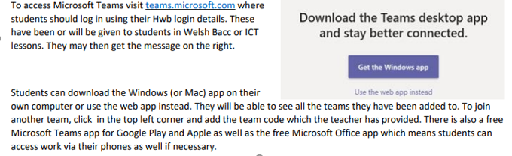

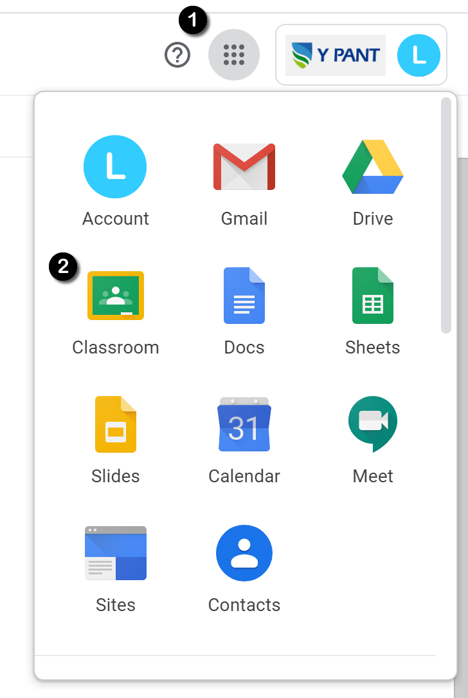
Google Classroom
Google Classrooms are online collaborative working environments for teachers and learners. Many classes have a Google Classroom and staff can post material, information and assignments in the classroom for pupils to view and complete.
To access Google Classrooms students should:
- Log in to their school Gmail.
- They will see the 9 dot icon the right-hand corner of the screen ❶
- By clicking this, students can access the full range of Google Suite for Education services including Google Classroom. ❷
- All of the classrooms a pupil has access to will appear in their browser so they can select the classroom of the subject they want to access.
- Google Classroom apps can also be downloaded for mobile devices and tablets and if push notifications are enabled, they will inform you of any new material or assignments as they are set.
HWB Teams
HWB Teams are online collaborative working environments for teachers and learners. Many classes have a Teams group and staff can post material, information and assignments in the classroom for pupils to view and complete.
To access HWB Teams students should:

Year Group Contact Details
Head of Progress | Mrs S. Nowell-Hughes | sixthform@ypant.co.uk
Assistant Head of Progress | Mrs K. Munday
Senior Leadership Link | Ms L. Bunce

Year 12 English
Topic Overview | Owen Sheers and Seamus Heaney poetry comparison  Jane Eyre studies
Assessed  Tasks | Extract questions on Y Gaer and Winter Swans by Sheers; on The Strand at Lough Beg by Heaney  Conflict essay on Sheers and Heaney’s poetry  Jane Eyre extract  Jane Eyre essay
Resources | See your class Teams for uploaded work.  Please contact your A Level teachers for copies of PowerPoints missed or tasks to be completed.
Year 12 Maths
Topic Overview | Unit 1 ( Pure maths)  Indices & Surds Rules of indices Manipulation of expressions involving indices Expanding and simplifying surds Rationalising the denominator My Maths  Quadratic Functions Inequalities (linear and quadratic) Nature of roots using discriminant Completing the square Maximum and minimum values of a function Solving equations using factors and formula methods My Maths  Differentiation Gradient of tangent as the limit of the gradient of the chord Differentiation from first principles Derivative as a rate of change 2nd derivatives Differentiating polynomials ^{d}/_{dx of} x^{n} = nx^{n-1} My Maths  Applications of Differentiation Identification of stationary points Use of 2nd derivative and 1st derivative to identify max., min. and points of inflection Optimisation problems Increasing and decreasing functions My Maths  Logarithms Laws of logarithms ( including proofs ) Solving equations of form a^{x} = b Know that ln x is the inverse function of e^{x} My Maths  Unit 2 ( Applied Maths)  Statistical Sampling Understand use and select or critique sampling techniques in the context of solving a statistical problem. Random sampling, systematic sampling and opportunity sampling My Maths  Data presentation and Interpretation Construct and interpret Histograms, cumulative frequency graphs and box plots Calculate standard deviation Interpret scatter diagrams and understand interpretation of correlation Recognize and interpret outliers in data sets. Select or critique data presentation techniques in the context of a statistical problem (being able to clean data) My Maths  .Probability Use Venn diagrams along with mutually exclusive and independent events when calculating probabilities.
Assessed  Tasks | Assessed homeworks  Half-term test
Resources | My Maths
Year 12 Further Maths
Topic Overview | See year 13 A level Maths  Year 12FM consists of A level Maths in one year.
Assessed  Tasks | Half-termly test
Resources | My Maths
Year 12 Biology
Topic Overview | Cells and Organelles - the nucleus, mitochondrion, endoplasmic reticulum, Golgi body, lysosomes, microtubules, ribosomes, vacuole, chloroplast, cell wall, eukaryotic vs prokaryotic cells, viruses, tissue organisation and microscopy.  Biological Molecules - Water, carbohydrates, triose sugars, pentose sugars, hexose sugars, disaccharides, polysaccharides, Lipids- Phospholipids, triglycerides
Assessed Task | Cell organelles assessed homework  Cell organelles test  Water and carbohydrates test  Lipids, carbohydrates and water test
Resources | School produced booklets and lab booklets.  Homework set via Teams / SIMS  Home Learning: Microsoft team - A team has been created for each class and this will be managed by individual class teachers. Check Teams for scheduled virtual lessons (this may not always be appropriate).  Bioninja website
Year 12 Chemistry
Topic Overview | Basic ideas about atoms and Radioactivity booklet:  Structure of the atom; Ionisation energy; Spectroscopy; Types of radiation; Nuclear equations; Half-life;
Assessed  Tasks | Worksheets at the back of the booklet.  End of unit test
Resources | Departmental booklets  WJEC revision booklet/website
Topic Overview | Introduction to Organic Chemistry, Hydrocarbons and Periodic Table Booklets  Naming Compounds; Identifying different types of reactions; Crude oil and hydrocarbons; Structure of alkenes;; Reactions of hydrocarbons and their derivatives; Trends and Reactions of elements in the Periodic Table.
Assessed Tasks | Key Tasks within the booklets.  End of booklet tests.
Resources | Departmental Booklets  WJEC revision booklet/website/past papers and mark schemes
Year 12 Physics
Topic Overview | 1. Uncertainty and Error Analysis  2. The Basics of Physics and Kinematics: Units and Prefixes, Vectors, Kinematics Definitions, Travel Graphs, Equations of Motion, g by Freefall, Projectiles.  3. Dynamics A: Newton’s Laws, Freefall and Terminal Velocity, Force Vectors.  4. Dynamics B: Momentum and Moments.  5. Solids Under Stress: Hooke’s Law, Young’s Modulus, Classification of Materials and Features of Force – Extension Graphs.  Skills include:  Numeracy, Literacy, Communication and Practical Skills, along with revision skills.
Assessed  Tasks | 1. No assessments  2. 3 assessed homework tasks, an entry test and an end of topic test.  3. 3 assessed homework tasks and an end of topic test.  4. 2 assessed homework tasks and an end of topic test.  5. 1 assessed homework task and an end of topic test.
Resources | Physics Booklets.  Watch appropriate scientific TV programmes.  Read appropriate Newspaper Articles.  New Scientist Magazine.  WJEC Physics for AS Level.  Mathematics for A Level Physics – a course companion.  Selection of Books available from department – ask teachers for advice. https://www.bangor.ac.uk/going-to-university/revision-guides/physics-en-2019  Teams Groups set up for each class.
Year 12 Art
Topic Overview | Unit 1 Personal Creative Enquiry.  Foundation skills unit (8 weeks) exploring The Formal Elements in Art and Design.  Coursework unit investigating the theme ‘Relationships’. They will choose an area they wish to pursue and will follow their chosen lines of enquiry to create a finished end piece(s). All work must be supported by a range of direct observation work in a range of media, Contextual research looking at relevant artists / designers / craft workers as well as development and ongoing evaluation.
Assessed  Tasks | Ongoing assessment of practical work.
Resources | Sketchbook  Drawing and colour based media  Teams classroom ls3ii6j  Museum and gallery websites  AS/A Level Art and Design (wjec.co.uk)
Year 12 Business
Topic Overview | - Understand different types of businesses and their objectives  - Understand how the functional areas of businesses work together to support the activities of businesses  - Understand the effect of different organisational structures on how businesses operate  - Be able to use financial information to check the financial health of businesses  - Understand the relationship between businesses and stakeholders  - Understand the external influences and constraints on businesses and how businesses could respond  - Understand why businesses plan  - Be able to assess the performance of businesses to inform future business activities
Assessed  Tasks | Class tests  October (section A)  November (section C)
Resources | https://ocr.org.uk/Images/294523-the-business-environment.pdf
Year 12 Computer Science
Topic Overview | KD  - Hardware and communication  - Logical operations  - Data transmission  OC  - Organisation of Data  - Database Systems  - Algorithms and Programs
Assessed  Tasks | Topic test on three topics listed above for KD
Resources | Class notes that should be taken home every lesson.  https://www.bbc.co.uk/bitesize/guides/z7qqmsg/revision/4  https://isaaccomputerscience.org/concepts/prog_concepts_logical?examBoard=all&stage=all  https://www.computerscience.gcse.guru/theory/data-transmission  https://www.computerscience.gcse.guru/theory/serial-parallel-data-transmission
Year 12 Design Technology
Topic Overview | Final AS Level coursework - folder work, sketchbook and practical
Assessed  Tasks | Investigating the problems, coming up with briefs, End User Profile, specification, Initial Ideas, design development and modelling.
Resources | TEAMS assignments
Year 12 Drama
Topic Overview | Unit 1: Theatre Workshop  - Frantic Assembly  - Verbatim Theatre - Laramie Project and London Road  Unit 2: Text in Theatre  - A View From the Bridge  - Actor/Director/Costume/Lighting/Sound/Set Design/  - Analyse and Evaluate live productions.
Assessed  Tasks | - Frantic Assembly Devising - Script and realisation  - Lighting Question - Mock AVFTB
Resources | Y12 Booklet  Vocab Booklet  AVFTB Revision Booklet  Access to TEAMS  Access to dramaonlinelibrary.com  Scripts:  ‘London Road’  ‘Laramie Project’  ‘A View From the Bridge’
Year 12 Government and Politics
Topic Overview | Unit 1-  The British Constitution  Unit 2-  Citizenship and rights in the UK | T
Assessed  Tasks | Timed essays and practice exam questions.
Resources | Keep up to date with UK news and politics via: https://www.bbc.co.uk/news/politics  https://www.theguardian.com/politics https://www.independent.co.uk/news/uk/politics  https://www.parliament.uk/ https://www.gov.uk/ https://gov.wales/ https://www.assembly.wales/en/Pages/Home.aspx https://www.walesonline.co.uk/allabout/politics  TEAMS code-  Miss Hodnett - 9lqom0b  Mrs Ingham -1pbl70x
Year 12 Geography
Topic Overview | Unit 1: Changing Landscapes  • Coastal Landscapes  • Tectonic Hazards  Unit 2: Changing Places
Assessed  Tasks | Three structured questions with stimulus material, one of which tests research/fieldwork
Resources | Microsoft Team set up for the cohort, code: lc6zlv4  All supporting resources on Teams in specification order.  he following websites and textbooks will also be useful:  http://www.worldwildlife.org/home.html  http://www.ace.mmu.ac.uk/resources/gcc/5-3-1.html  http://www.ecn.ac.uk/environmental_indicators.htm  http://en.wikipedia.org/wiki/Kyoto_Protocol  http://www.rgs.org/OurWork/Schools/Resources/Case+studies.htm  http://www.geonet.org.nz/index.html  http://www.esta-uk.org/main.html  http://volcano.und.edu/vwdocs/kids/vrtrips.html  Hazards and responses, Victoria Bishop,Collins Educational, 1998, p67 & 125-138  Advanced geography, Concepts and Cases, Paul Guiness, Garrett Nagle  Geography: An Integrated Approach, David Waugh, Nelson Thornes 3rd ed 2002  The WJEC revision guides may be useful:  Unit 1 Changing Landscapes: https://www.hoddereducation.co.uk/subjects/geography/products/a-level-(1)/wjeceduqas-as-a-level-geography-student-guide-2  Unit 2: Changing Places: https://www.amazon.co.uk/Eduqas-level-Geography-StudentGuide/dp/1471864057/ref=sr_1_8?dchild=1&keywords=wjec+as+geography+revision+guide&qid=1599815880&s r=8-8
Year 12 History
Topic Overview | Unit 1  The History of Wales and England 1780-1880  The first half of the AS course namely:  - The Tory party 1815- 1830  - Popular Protest  Unit 2  - Weimar Germany 1918-1923
Assessed  Tasks | Timed essays and source analysis tasks, towards the end of this half term. Time and date to be determined.  Past paper exam questions.
Resources | School produced booklets  History channel  Youtube  TEAMS CODE Mr Sweet- 12B - q16vx3h 12E - br7z5cx  Miss Hodnett- q16vx3h
Year 12 ICT
Topic Overview | Unit 1- Fundamentals of ICT (KD)  - Computer Components  - Types of computer systems  - Connectivity  Unit 2 - Global Information (OC)  - Devices and the Internet  - Information Styles  - Categories and Analysis
Assessed  Tasks | Unit 1- Test based on the 3 topics for Unit 1 above  Unit 2- Test based on 3 topics listed for Unit 2 above
Resources | The following website will guide you through all the topics listed above and also offers key questions at the bottom of each page to practice:-  https://www.csnewbs.com/ocr-cambridge-technicals
Year 12 Music
Topic Overview | Unit 2 - Composition  FREE COMP PREPARATION  Unit 3 - Appraisal  JAZZ AND WESTERN CLASSICAL
Assessed  Tasks | APPRAISAL -  BACH CHORAL/HAYDEN - SYMPHONY 1 & 3 AND 45  JAZZ APPRAISAL AND THEORY - CHET BAKER/TAKE 5
Resources | Please find work and resources on TEAMS.
Year 12 Media Studies
Topic Overview | Section A - representation in print texts - adverts and charity materials.  Section C - Teen movie genre
Assessed  Tasks | Section A - Analysis of a print text  Section C - Essay on genre
Resources | Check Teams for relevant resources.  Use Youtube for explanation videos
Year 12 Physical Education
Topic Overview | Unit 1; Topics cover - Exercise Physiology; Sports Psychology and Socio Cultural Issues in Sport  Each of the three teachers will provide a specific topic from above.
Assessed  Tasks | Past paper questions for each topic above.
Resources | TEAM CODE: 9mhth2q  School produced work booklet  Any homework will be on teams; pupils should work through workbook used in class if off with COVID.  WJEC Resources - https://resources.wjec.co.uk/pages/ResourceByArgs?subId=23
Year 12 Psychology
Topic Overview | Completing the research methods topic (unit 2).  Book 1 - aims, hypotheses, variables, ethics, reliability and validity  Book 2 - location of research, research types, sampling, experimental design  Book 3 - data analysis  Live lessons will be available if unable to attend.  All class materials uploaded to teams and students must save their own copy before editing
Assessed  Tasks | Practice questions for each booklet preparing for the main assessment  Assessment at the end of each of the 3 booklets (3rd one will feed into next half term)  Self-assessed past paper questions
Resources | 3 booklets  Teams group - class code - ke5mrdq for 12C (Tuesday/Thursday class)  - 0n2kk5t for 12 D (Monday/Wednesday class)  www.bps.org.uk research relevant and most recent research published  Text book will be needed after half term. Link is to amazon but can be purchased elsewhere (check publication date is 2015) https://www.amazon.co.uk/Complete-Companions-WJEC-Psychology-PSYCHOLOGY/dp/0198359179/ref=sr_1_6?dchild=1&keywords=as+psychology+text+book&qid=1632824647&qsid=257-0550999-5044616&sr=8-6&sres=0198356102%2C1845900936%2C1912820420%2C0198359179%2C1447982460%2C1782943307%2C0198436327%2C0198332750%2C190868240X%2C0340966831%2C1471835901%2C1510483012%2C1912820463%2C1471834883%2CB07GRBB9WQ%2C1510468676&srpt=ABIS_BOOK
Year 12 Sociology
Topic Overview | Unit 1- Acquiring Culture- Booklet 1 - This half term we will be working through this booklet - reading the notes and then completing all set tasks throughout. This will inform the end of the unit test that will consist of 2 exam style questions. Accompanying pp will be uploaded to our class Teams account.  Unit 2 - Approaches to Sociological Research - working through the yello booklet. All handouts and PowerPoints in Teams. Look in Files in the “Ms Bunce” channel.
Assessed  Tasks | End of Unit Test on the Acquiring Culture Booklet  Past paper question on research methods.
Resources | Text book  Unit 1 Acquiring Culture Booklet  Unit 2 Approaches to Sociological Research Booklet  Teams
Year 12 Welsh Baccalaureate
Topic Overview | Global Challenge Task 1 & 2
Assessed  Tasks | You should outline your approach to tackling the issue by constructing a clear, coherent, well-argued and convincing argument, viewpoint or perspective, offering creative and innovative approaches to tackle the issue.
Resources | Google Classroom
Year 12 REP
Topic Overview | Hinduism  Theme 4: : Religious practices that shape religious identity (part 1)  - Puja in the home and the mandir  - Festival - Holi  - Festival - Durga Puja  Ethics  Theme 1: Ethical Thought:  - Divine Command Theory  - Virtue Theory  - Ethical Egoism  Philosophy  Theme 1: Arguments for the Existence of God - Inductive:  - The Cosmological Argument  - The Teleological Argument  - Alternative Views
Assessed  Tasks | Hinduism:  - Essays on knowledge and understanding of the theme  - Essays on the issues/evaluation of the theme  Ethics:  - Explain the Divine Command Theory. [30]  - ‘Morality is what God commands’. Evaluate. [30]  Philosophy Essay Titles:  - Explain the Cosmological Argument for God’s existence. [30]  - ‘The Kalam Cosmological Argument is Unconvincing’. Evaluate. [30]
Resources | - Booklets  - PowerPoints on Teams  - WJEC website  - Philosophy Ninja Channel (YouTube)

