Year 11 Autumn Term Curriculum Plan 1
This document is designed to provide an overview of the content of the curriculum that each department will be addressing over the Autumn Term. Each department has provided information on the topics/ content addressed, resources being used and information on tasks that will be assessed. If you have any queries please direct these into the Progress Team on the email address below as a primary point of contact.
Communication Tools
Teachers may be sending activities home for pupils using one of three methods: Teams, Gmail or Google Classroom. All pupils have a Gmail address which allows them to access Google Classroom. The address is their 6 digit user number @ypant.co.uk and the password will be the same as the one they use to log into the computer at school.
HWB Teams
HWB Teams are online collaborative working environments for teachers and learners. Many classes have a Teams group and staff can post material, information and assignments in the classroom for pupils to view and complete.
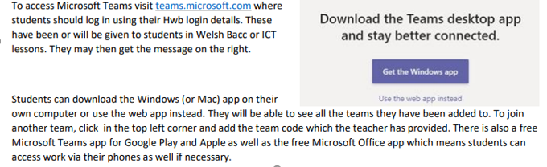
To access HWB Teams students should:

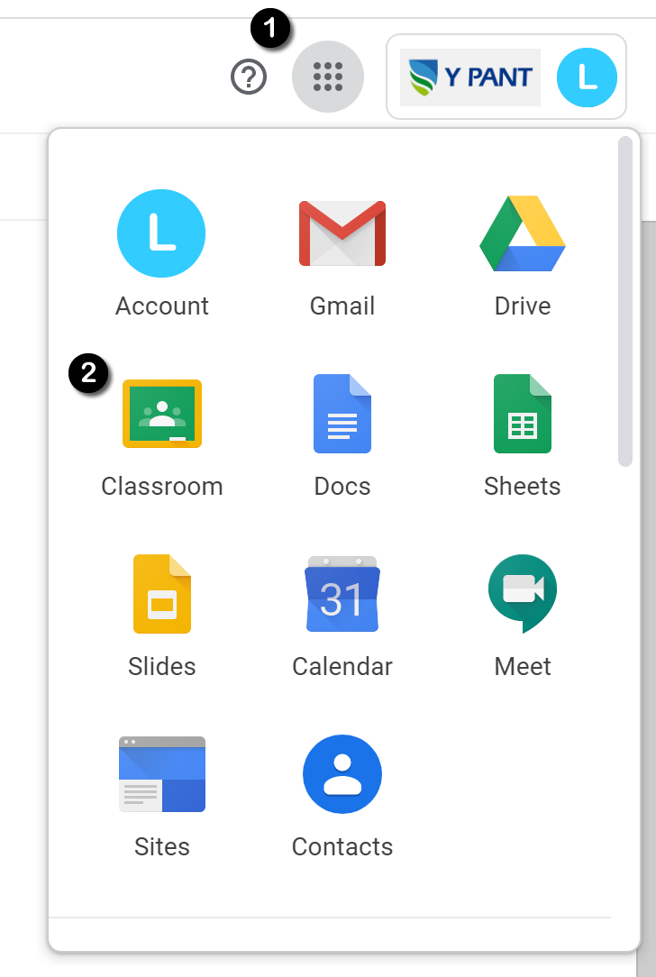
Google Classroom
Google Classrooms are online collaborative working environments for teachers and learners. Many classes have a Google Classroom and staff can post material, information and assignments in the classroom for pupils to view and complete.
To access Google Classrooms students should:
- Log in to their school Gmail.
- They will see the 9 dot icon the right-hand corner of the screen ❶
- By clicking this, students can access the full range of Google Suite for Education services including Google Classroom. ❷
- All of the classrooms a pupil has access to will appear in their browser so they can select the classroom of the subject they want to access.
- Google Classroom apps can also be downloaded for mobile devices and tablets and if push notifications are enabled, they will inform you of any new material or assignments as they are set.

Year Group Contact Details
Head of Progress | Mr L Jones | 2022@ypant.co.uk
Assistant Head of Progress | Mrs Stone
Senior Leadership Link | Mrs Burnell

Year 11 English
Topic Overview | GCSE English Language  Preparing for examination question by studying the following reading question types:  Summary, how does the writer, synthesis, comparison, explain how, explain why, impressions, thoughts and feelings, editing and proof-reading  Preparing for examination question by studying the following writing tasks:  Exposition, descriptive, persuasive and argumentation writing (letters, articles, speeches)
Assessed  Tasks | Mini mock in November (reading questions only)  Full Mock (reading and writing questions)
Resources | See your class Teams for uploaded past papers to practise.  Complete the uploaded tasks and documents by your class teacher.
Year 11 Maths
Topic Overview | Please refer to the resources section as preparation for forthcoming exams.  Foundation Tier:  § Finding information from graphs  § Conversion graphs – reading and drawing  § Travel graphs  § Drawing graphs from tables  § Reading tables  § Frequency tables  § Practical survey  § Bar charts and pictograms  § Pie –charts  § S§ Mean of a set of numbers  § Mode of a set of data – multimodal and no mode  § Median including an even no. of values  § Mode from a graph  § Range  § Practical data collection and analysis  Scatter graphs – correlation, line of best fit  § Drawing triangles  § General drawing  § Drawing to scale  Intermediate Tier:  § Possibility space  § Independent events  § Mutually Exclusive events  § Probability tree diagrams  § Cumulative frequency graphs  § Box and whisker diagrams  § Straight lines  § Quadratics  § Simple algebraic inequalities  Higher Tier  § Graphs of sin, cos, tan.  § Solving equations by using these graphs  § Independent events  § Methods of calculating probabilities  § Conditional probabilities  § Revision of percentages  § Simple & compound interest  § Appreciation & depreciation  § Household bills, VAT, income tax  § Exchange rates  § Vertical translation  § Horizontal translation  § Combined transformations & function notation
Assessed  Tasks | Mock exams 5th and 6th October  WJEC Numeracy Exams: 2nd and 4th November
Resources | www.mymaths.co.uk  user name: ypant  Password: hexagon  Use WJEC past papers and markschemes as preparation for forthcoming Numeracy exam  Use https://www.mathsdiy.com/gcse-numeracy-past-papers/ as preparation for forthcoming Numeracy exam
Year 11 Biology
Topic Overview | Response and Regulation:  Triple Award  Sense organs, reflexes, the reflex arc, blood glucose regulation, the eye, temperature control, lifestyle choices and disease and tropisms.  Double Award  Sense organs, reflexes, reflex arcs, blood glucose regulation, temperature control and lifestyle choices and disease..
Assessed Tasks | Response and Regulation assessed homework.
Resources | School produced booklets  Homework set via Teams / SIMS  Home Learning: Microsoft team - A team has been created for each class and this will be managed by individual class teachers. Check Teams for scheduled virtual lessons (this may not always be appropriate).  GCSE Bitesize - Key Stage 4
Year 11 Chemistry
Topic Overview | For all course:  Acids Bases and Salts booklet:  The pH scale; Reactions of acids with metals, metal oxides, metal carbonates and alkalis.  Triple Award only:  Titration calculations
Assessed  Tasks | Assessed homeworks, see booklet.  Checklist  End of booklet test.
Resources | GCSE bitesize  WJEC webpage  Y Pant booklets
Year 11 Physics
Topic Overview | 11 DA Physics Foundation/DA Physics Higher/Separate Physics (Pupils in different classes will be studying the booklets below in different orders)  1. Speed and Travel Graphs: Speed and Acceleration, Distance-Time Graphs and Speed – Time Graphs.  2. Forces: Balanced and Unbalanced Forces, Newton’s Laws, Weight and Mass, Freefall and Terminal Velocity, Car Stopping Distances and Car Safety Features  3. Work and Energy: Work Done, KE and GPE, Energy Transfers, Car Safety Features and Springs and Hookes Law.  4. Types of Radiation: Why Radioactive?, Safe Disposal of RA Waste, Background Radiation, Types Of Radiation and Nuclear Terminology/Equations.  5. ½ Life: Half Life and Uses of Radiation.  6. Stars and Planets: Solar System, Distances in Space, Star Life Cycle and the Formation of the Solar System, HR Diagram.  Note that Separate Physics will also be studying Nuclear Energy: Nuclear Fission and Nuclear Fusion.  Skills include:  Numeracy, Literacy, Communication and Practical Skills, along with revision skills.
Assessed  Tasks | 1. Past paper Questions on Speed and Travel Graphs, marked in class. End of Topic Test – Speed and Travel Graphs  2. Past paper Questions on Forces, marked in class. Assessed homework on Newton’s Laws, Freefall and terminal Velocity. End of Topic Test – Forces.  3. Past paper Questions on Work Done, KE and GPE, Energy Transfers, Car Safety Features and Springs and Hookes Law, marked in class. Assessed homework on: Work Done, KE and GPE, Energy Transfers and Car Safety Features. End of Topic Test - Work and Energy and Springs and Hookes Law.  4. Past paper Questions on Why Radioactive?, Safe Disposal of RA Waste, Background Radiation, Types Of Radiation and Nuclear Terminology/Equations, marked in class. Assessed homework on: Why Radioactive?, Safe Disposal of RA Waste, Background Radiation, Types Of Radiation. End of Topic Test - Types of Radiation.  5. Past paper Questions on Half Life and Uses of Radiation, marked in class. Assessed homework on: Half Life. End of Topic Test - Half Life and Uses of Radiation.  6. Past paper Questions on Solar System, Distances in Space, Star Life Cycle and the Formation of the Solar System, HR Diagram, marked in class. Assessed homework on: Solar System, Distances in Space, Star Life Cycle and the Formation of the Solar System, HR Diagram. End of Topic Test - Solar System, Distances in Space, Star Life Cycle and the Formation of the Solar System, HR Diagram.  Nuclear energy: Past paper Questions on Nuclear Fission and Nuclear Fusion, marked in class. Assessed homework on: Fissions and Fusion. End of Topic Test - Fission and Fusion.
Resources | Physics Booklets.  www.thestudentroom.co.uk.  www.gcse.com.  www.fizzics.org/gcse-physics-notes-and-video.  www.bbc.co.uk/schools/gcsebitesize.  Watch appropriate scientific TV programmes.  New Scientist Magazine. https://www.crickhowell-hs.powys.sch.uk/wp-content/uploads/2018/03/GCSE-Physics-Unit-1-RevisionBook-2018.pdf. Year 11  Teams Groups set up for each class.
Year 11 Art
Topic Overview | Completion of Portfolio based on ‘Structures’ theme.  Students will have completed a 3d or Print project and will progress on to the other unit once all work is complete and evident in the Portfolio.
Assessed  Tasks | Ongoing assessment of classwork and homework tasks.
Resources | Sketchbook  Drawing materials  Museum / Gallery websites  Teams classroom JAG 5n2hra0 SNH ykpv4aj HH b52w9qp  GCSE Art and Design - BBC Bitesize  GCSE Art and Design (wjec.co.uk)
Year 11 Business
Topic Overview | Marketing  - Market segmentation  - Product  - Price  - Place  - Promotion  - Market research  Preparation for mock examination
Assessed  Tasks | October - 10 mark question marketing  November - test preparation ready for mock, mixed questions (topics to be decided)  December - mock examination - whole GCSE content
Resources | https://www.bbc.co.uk/bitesize/topics/z96pyrd  https://www.wjec.co.uk/qualifications/business-gcse/#tab_overview
Year 11 Spanish
Topic Overview | El ocio y el tiempo libre  Free time activities and reasons to do them, TV, music…  Grammar : past tense
Assessed  Tasks | Written and oral tasks at the end of the unit
Resources | Spanish and grammar booklets  Quizlet to learn all your vocabulary  Kahoot, Blooket and Gimkit to practice your vocabulary  The work completed in class is sent out to pupils at home.  Make sure you check your Gmail on the days you have your Spanish lessons.  Feel free to email your teacher if you wish to join your Spanish lesson at home.
Year 11 Computer Science
Topic Overview | Unit 1 (KD) -Cyber security -  - The characteristics and methods of protection against malware, including viruses, worms and key loggers.  - The different forms of attack based on technical weaknesses and/or user behaviour.  - Describe methods of identifying vulnerabilities.  - Different ways of protecting software systems during design, creation, testing and use.  - The role of internet cookies  - Ethical, legal and environmental impacts of digital technology on wider society  Unit 2 (OC)  - Program Solving & Designing Algorithms
Assessed  Tasks | Topic Test on Data Management and Security  Topic test on Ethical, legal and environmental impacts of digital technology on wider society
Resources | Revision guide on Google Classroom Topics 8 & 9  https://www.tutorialspoint.com/programming_methodologies/programming_methodologies_writing_the_algorithm.htm
Year 11 Construction
Topic Overview | UNIT 3 Practical Construction Skills
Assessed  Tasks | Carpentry, Tiling and Grouting, Household Electronics.
Resources | Construction Booklet.  Class TEAMS assignments.
Year 11 Drama
Topic Overview | Unit 1: Devising Theatre  COURSEWORK = 40% OF QUALIFICATION  DEADLINE 21ST OCTOBER
Assessed  Tasks | - Creative Log = 900 words + illustrative evidence (DEADLINE 24TH SEPT)  - Rehearsed performance (monologue/group) (DEADLINE 20TH OCTOBER)  - Evaluation = 900 words (DEADLINE 21ST OCTOBER)
Resources | Year 10 Booklet (Final pages)  TEAMS with Ms Roberts - work set via TEAMS and SIMS
Year 11 Engineering
Topic Overview | Plug Disassembly and Analysis - Main Project Context
Assessed  Tasks | Plug Disassembly and Analysis
Resources | Work on TEAMS.  In - class activities.  Engineering booklet.
Year 11 Food and Nutrition
Topic Overview | Types and nutritional value of meat  Composition of meat.  Storage and cooking of meat  Alternative protein foods
Assessed  Tasks | Meat test  Chicken practical  Meatball practical
Resources | All the classes have a team. Resources will be uploaded on their team for pupils to access.
Year 11 French
Topic Overview | Travel & Transport Topic 2 a & 2b  Healthy Lifestyles & Hobbies and Entertainment Topic 4a & 4b
Assessed  Tasks | Extended writing, Structured Conversations, Role Play. Exam Practise questions
Resources | Dept Booklets  Quizlet Past Papers
Year 11 Geography
Topic Overview | Core Theme 2: Rural-Urban Links  Key Idea 2.3: Urban issues in contrasting global cities  Core Theme 5: Weather, Climate and Ecosystems  Key idea 5.1 Climate change during the Quaternary period  Key idea 5.2 Weather patterns and processes  Unit 3: Fieldwork Enquiry
Assessed  Tasks | Two structured data response questions with extended writing.
Resources | Microsoft Team set up for the cohort, code: aq3limw  All supporting resources on Teams in specification order. The WJEC GCSE Geography revision guide may be useful:  https://www.hoddereducation.co.uk/subjects/geography/products/14-16/my-revision-notes-wjec-gcsegeography
Year 11 History
Topic Overview | NEA COURSEWORK- Life in the trenches.  Preparation for WJEC set assignment, the preparations work can be completed remotely however the examined piece of work will be completed in school under exam conditions towards the end of this half term.
Assessed  Tasks | WJEC NEA Assessment 1. Source analysis task.
Resources | School based resources.  Teams code-  Miss Hodnett -11B- t3a6scf  Mr Sweet- 11C- zcnnegi  Mrs Ingham-
Year 11 Health and Social Care
Topic Overview | Nea Task 1 - Service provision
Assessed  Tasks | Nea Task 1 - Service provision  Sections A, B and C
Resources | Teams classroom code for VK and GC- 1v5af4u
Year 11 ICT
Topic Overview | Unit 3 (KD)  - Data logging and Control  - Web and Presentation Software  Unit 2 & 4 (OC)- Restrictions have been lifted for only this work to be carried out in the classroom so pupils can carry on with work within these units at home. Improvements and modifications can be made.
Assessed  Tasks | Class test based on 2 units above- Past paper exam questions
Resources | School Based Notes  Data loggin and control -https://www.teach-ict.com/gcse_new/control/data_logging/miniweb/index.htm  Web and Presentation Software - https://www.teach-ict.com/gcse_new/software/presentation/miniweb/index.htm  https://resources.wjec.co.uk/Pages/ResourceByArgs.aspx?subid=18&lvlid=2  Coursework support  Unit 2 -https://www.wjec.co.uk/umbraco/surface/blobstorage/download?nodeId=7196  Unit 4 - https://www.wjec.co.uk/umbraco/surface/blobstorage/download?nodeId=30834
Year 11 Life Skills
Topic Overview | Finance qualification  Sets 1 - 3: Award in Financial Education.  Sets 4 - 5: Lessons in Financial Education
Assessed  Tasks | Sets 1 - 3: Work through their booklet using the powerpoint to help. Complete activities and quizzes when instructed- quizzes can be done on the LiBF website as well. If pupils need their login details then they need to contact their teacher or Mrs Dowling.  Sets 1 - 4: Work through the PowerPoints on Teams and complete the online activities on the LiBF site when instructed. Most pupils are currently on topic 2 but some are ready to start topic 3. If pupils need their login details then they need to contact their teacher or Mrs Dowling.  Pupils also need to ensure their Equality and Diversity work from last year is complete.
Resources | All are on Teams  Code for sets 1 - 3: 5492vlo  Code for sets 4 - 5: eou2t4t
Year 11 Music
Topic Overview | UNIT 1 - Performance prep  UNIT 2 - Composition prep  UNIT 3 - Appraisal Prep
Assessed  Tasks | Individual Performance mock  Composition free - mock  Appraisal Q7/8
Resources | Please find work on TEAMS and Bandlab set by MrG/MrsM
Year 11 Media Studies
Topic Overview | Exam: U1B Music Industry, focusing on Music videos  NEA: Research and Planning elements
Assessed  Tasks | Key Task: Analysing of representation of gender in the music video for Taylor Swift’s ‘The Man’. Use teh resources in the booklet as well as watching the video on Youtube, to guide your learning and analysis of the text.  Research and Planning elements of NEA uploaded to Teams. Deadline for research has passed. Deadline for planning 2nd October. Use all the resources on Teams to guide you through planning the Cover, contents page and third page of your magazine. Ensure you conform to the brief and check the mark scheme.
Resources | U1B Booklet - hard copy and uploaded on Teams  NEA resources uploaded on Teams  Adobe Spark, accessed through Hwb
Year 11 Physical Education
Topic Overview | Recap Unit 1 and 2  Revisit and complete Unit 3 - Movement Analysis
Assessed  Tasks | Key Task - movement analysis;  Booklet topic questions
Resources | School produced booklets - Unit 3  Homework set via Teams - each class has their own.  Home Learning: Microsoft teams - A team has been created for each class and this will be managed by individual class teachers.  GCSE Bitesize - Key Stage 3/4; WJEC - Physical Education
Year 11 Sport
Topic Overview | Unit 3 - Coaching Principles
Assessed Tasks | Assessed in their ability to coach others in a practical setting
Resources | Homework set via Teams - each class has their own.  Home Learning: Microsoft teams - A team has been created for each class and this will be managed by individual class teachers.  GCSE Bitesize - Key Stage 3/4; WJEC - Physical Education
Year 11 Religion, Ethics and Philosophy
Topic Overview | Relationships: Christianity and Judaism:  - Religious attitudes towards family  - Nature and purpose of marriage  - Marriage outside religious traditions/ Inter-faith marriage  - Cohabitation  - Adultery  - Divorce  - Religious attitudes towards sex  - Contraception  - Same-sex relationships  - Roles of women and men in worship and authority
Assessed  Tasks | - Exam questions  - End of unit test
Resources | - Booklet  - Teams  - BBCBitesize - KS4: Relationships  - WJEC Website- Resources - Religious Studies - Unit 2 Relationships
Year 11 Product Design
Topic Overview | Final GCSE coursework - folder work and practical
Assessed  Tasks | Investigating the briefs, End User Profile, Initial Ideas.
Resources | TEAMS assignments
Year 11 Welsh
Topic Overview | Ieuenctid (Youth) - School (subjects, likes & dislikes, school uniform, rules, problems in school, the future)
Assessed  Tasks | Key task - Unit 4 style writing question  Key task - Unit 2 style speaking assessment
Resources | All resources and PowerPoints will be uploaded to Teams at the beginning of each week. A team has been created for each class and this will be managed by individual class teachers.  Additional resources:  www.s4c.cymru/clic(Catch-up TV)  www.geiriadur.net (dictionary)  Download ‘Ap Geiriaduron’ - free dictionary app to your phone or tablet for instant translation of words.
Year 11 Welsh Baccalaureate
Topic Overview | Individual project  Pupils complete a 2000 word project on their chosen topic.
Assessed  Tasks | October - title/aims/objectives  November - main body  December - personal reflection
Resources | https://www.wjec.co.uk/qualifications/welsh-baccalaureate-national-foundation/?sub_nav_level=course-materials#tab_resources

